ONEWAY Memory BY FPS
/STATISTICS DESCRIPTIVES HOMOGENEITY WELCH
/PLOT MEANS
/MISSING ANALYSIS.

Oneway

Notes
Output Created |  | 06-May-2019 00:01:19
Comments
Input | Active Dataset | DataSet0
Input | Filter | <none>
Input | Weight | <none>
Input | Split File | <none>
Input | N of Rows in Working Data File | 30
Missing Value Handling | Definition of Missing | User-defined missing values are treated as missing.
Missing Value Handling | Cases Used | Statistics for each analysis are based on cases with no missing data for any variable in the analysis.
Syntax |  | ONEWAY Memory BY FPS  /STATISTICS DESCRIPTIVES HOMOGENEITY WELCH  /PLOT MEANS  /MISSING ANALYSIS.
Resources | Processor Time | 00 00:00:00.172
Resources | Elapsed Time | 00 00:00:00.183

[DataSet0]

Descriptives
 | N | Mean | Std. Deviation | Std. Error | 95% Confidence Interval for Mean
 |  |  |  |  | Lower Bound | Upper Bound
30 FPS | 13 | 119.0000 | 35.32601 | 9.79767 | 97.6527 | 140.3473
60 FPS | 17 | 75.5935 | 15.83928 | 3.84159 | 67.4497 | 83.7373
Total | 30 | 94.4030 | 33.66618 | 6.14658 | 81.8318 | 106.9742

Descriptives
 | Minimum | Maximum
30 FPS | 67.50 | 166.00
60 FPS | 48.00 | 106.25
Total | 48.00 | 166.00

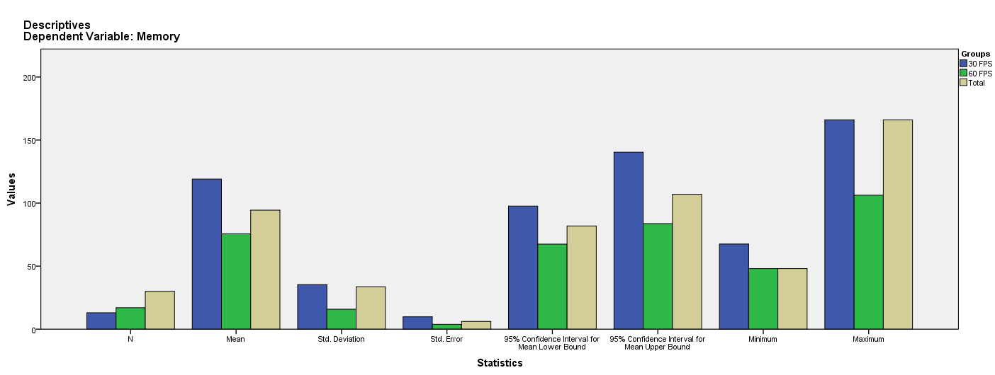

Test of Homogeneity of Variances
Memory
Levene Statistic | df1 | df2 | Sig.
15.128 | 1 | 28 | .001

ANOVA
Memory
 | Sum of Squares | df | Mean Square | F | Sig.
Between Groups | 13879.696 | 1 | 13879.696 | 20.466 | .000
Within Groups | 18989.248 | 28 | 678.187
Total | 32868.945 | 29

Robust Tests of Equality of Means
Memory
 | Statisticª | df1 | df2 | Sig.
Welch | 17.012 | 1 | 15.695 | .001
a. Asymptotically F distributed.

Means Plots

